Response Team Incident Action Plan

Confidential – Internal Incident Communication
Audience | Response Team: IT, Development, QA, Project Management, Legal, Client Services, HR
From | IT Operations Manager
Date | June 2, 2026
Subject | Plan to resolve the critical scheduling update error
Scenario | Scenario 2: Critical Error

Purpose and Current Status
This plan coordinates the cross-functional response to the critical scheduling update error. The flawed build could permit unlimited services instead of the contracted one service per purchase. The root cause is a process-compliance failure: one developer commit was not reviewed, and QA sign-off was bypassed for 12 modules. The defect was found four days after staging deployment, before the scheduled client production release (Western Governors University [WGU], n.d.).
Our objective is to prevent production deployment of the flawed build, correct and retest the affected code, prepare a controlled client communication plan, and put preventive controls in place so a QA bypass cannot recur.

Incident Response Priorities
- Protect the client from a faulty production release and the related first-30-day revenue exposure.
- Hit a realistic corrected-release window of about 12 days after incident confirmation.
- Maintain one source of truth for status, risks, blockers, and client-facing information.
- Capture lessons learned without blame so the team can strengthen release controls.
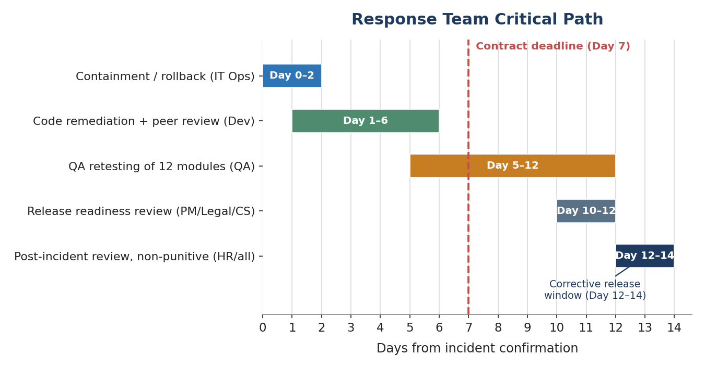
Figure 1. Response team critical path. The dashed line marks the contract deadline on Day 7; the corrective release follows full QA sign-off in the Day 12–14 window.

Roles and Responsibilities
Function | Primary responsibility | Key task | Update cadence
IT Operations | Containment and release control | Freeze promotion of the flawed build, manage rollback, and coordinate operational readiness. | Twice daily until rollback complete; daily after.
Development Lead | Code remediation | Fix the scheduling-limit logic and verify peer review of the originally unreviewed commit. | Daily by 4 p.m.
QA Lead | Testing and sign-off | Retest all 12 bypassed modules and confirm 100% QA compliance before release. | Daily by 4 p.m.
Project Management | Schedule and dependencies | Own the incident timeline, blockers, staffing needs, and release-readiness checklist. | Daily status report.
Legal | Contract and risk review | Assess SLA exposure and review all client-facing language before it is sent. | As needed; required before client messages.
Client Services / Account Mgr. | Client communication | Prepare status updates, the expected delivery window, and the support-readiness plan. | Daily client-ready update.
HR | People and process support | Support coaching, policy reinforcement, and a non-punitive post-incident learning process. | Postmortem and follow-up.

Execution Process
Day 0–2 – Containment: freeze the flawed build, roll back the staging artifact from the release path, and document the affected modules.
Day 1–6 – Remediation: Development corrects the scheduling authorization logic and completes peer review before QA intake.
Day 5–12 – QA retesting: QA completes regression testing and validates that one purchase permits only one service.
Day 10–12 – Release readiness: Project Management confirms checklist completion; Legal and Client Services approve client-facing messaging.
Day 12–14 – Post-incident review: the team reviews root cause, control gaps, and prevention actions, focusing on process improvement rather than individual blame.

Open Dialogue and Lessons Learned
Every function should raise risks, blockers, and control gaps immediately. The post-incident discussion should answer three questions: where did the release process allow a QA bypass, what automation or approval gate would have stopped it, and what training or documentation change would help the team avoid a repeat.

Prevention Targets
- Zero QA bypasses for release-bound code, with 100% QA-check compliance required before any production promotion.
- Automated code-review coverage for 90% of new commits by Q3.
- Annual prevention budget of about $250,000 for tooling and training, justified against the potential loss of a single $500,000 client contract.
- Post-release monitoring of scheduling anomalies and client-complaint trends during the first week after the corrective release.

References
Western Governors University. (n.d.). E011.1 Technical communication: Scenario 2 – Critical error [Course scenario].

